Multi-objective Optimization of Cutting Parameters for CNC Turning 42CrMo4 Hardened Steel Using Utility Function

Hristo Metev
dept. Mechanical engineering and technology
Technical University of Gabrovo
Gabrovo, Bulgaria
hmetev@abv.bg
Irina Aleksandrova
dept. Mechanical engineering and technology
Technical University of Gabrovo
Gabrovo, Bulgaria
irina@tugab.bg
Nikolay Kolev
dept. Mechanical engineering and technology
Technical University of Gabrovo
Gabrovo, Bulgaria
nikikolev@abv.bg

Abstract—The optimum turning conditions for 42CrMo4 hardened steel, defined and recommended in the literature, are valid only for certain cutting tools and machine tools. In this paper, an attempt has been made to optimize the cutting parameters for CNC turning with robotic power supply of the machine tool by using a new type of CVD coated replaceable carbide insert as cutting tool. To determine the optimal cutting conditions such as cutting speed, feed and depth of cut, a multi-objective optimization, based on a genetic algorithm, was conducted. The generalized arithmetic mean utility function with weighting coefficients has been chosen as the optimization parameter, which is a complex index characterizing the cutting tool lifetime and production rate in turning. The optimization problem has been solved in the following sequence: 1) a model of the generalized utility function was created, reflecting the complex influence of the turning process parameters; 2) the optimal cutting conditions were determined, under which the generalized utility function has a maximum; 3) Pareto optimal solutions were found, which guarantee the best combination between tool lifetime and production rate in turning.
Keywords—multi-objective optimization, generalized utility function, CNC turning, 42CrMo4 hardened steel.

Introduction
Improvement of manufacturing processes for machining, including the turning process, is of paramount importance in modern mechanical engineering. Increasing the production rate of these processes, as well as the toollife of cutting tools and the quality of machined surfaces is guaranteed by the selection of optimal conditions for machining materials with different physical and mechanical properties, using modern optimization methods and algorithms [1], [2].
One of the most commonly used materials for the production of important parts with high strength and hardness (compressor parts, turbine parts, working elements of heavy ground and underground machinery, parts for agricultural machinery) on CNC lathes is the hardened medium-carbon low-alloy steel 42CrMo4+QT. The optimum conditions for its machining by turning as defined and recommended in technical literature are valid only for certain cutting tools and machine tools, as well as for a certain hardness of the machined material. Roughness of machined surfaces, cutting tool lifetime/tool wear, chip formation/chip breaking, production rate, cutting forces and cutting power were used as optimization parameters [3] – [10]. Their optimum values were obtained for different combinations of values of the control factors of the turning process (cutting speed, depth of cut, feed, cutting tool geometry). Both conventional (Taguchi method, Response surface design methodology, Iterative mathematical search technique - linear, non-linear, and dynamic programming techniques) and unconventional (heuristic search technique, metaheuristic search technique - Genetic algorithm (GA), Tabu search (TS), Simulated annealing (SA)) techniques have been used to define them.
The analysis of the results presented in Refs. [1], [2], [11] - [16] shows that the multi-objective optimization of turning process parameters offers a greater amount of information for making a reasoned decision for selecting optimal conditions, and the generalized utility function method is one of the most commonly used multi-objective optimization methods in industry. With this method, researcher can easily determine the optimal parameters in the group of solutions. The generalized utility function has many advantages over other combination methods mainly due to its flexibility, as it allows to simultaneously maximize some of the output quantities and minimize others [1], [15], [16].
In spite of the large number of optimization studies of the turning process, there is no evidence in the literature for defined optimum conditions for machining hardened 42CrMo4 steel on a CNC turning machine with robotic power supply.
This paper presents the results of the multi-objective optimization based on the generalized utility function method of the CNC turning process parameters with robotic power supply of the machine tools, using a new type of CVD-coated replaceable carbide insert as the cutting tool. The optimum values of the cutting conditions (cutting speed, feed and depth of cut) were determined to ensure the best combination between tool life and production rate.

Materials and methods
The multi-objective optimization of the hard turning process for 42CrMo4 steel (Table 1 [17]) boils down to determining cutting conditions - cutting speed $V_{c}^{*}$ (m/min), feed $f^{*}$(mm/rev) and depth of cut $a_{p}^{*}$ (mm), that provide a combination between maximum cutting tool lifetime and maximum production rate of process. To solve the optimization problem, the generalized arithmetic mean utility function with weighting coefficients $Φ_{A}$ is chosen as the optimization parameter. It is a complex indicator determining the turning process parameters - tool lifetime and production rate in turning.
Cutting tool lifetime is determined by the distance L (mm) travelled by the tool on the machined surface, determined when machining a certain number of workpieces in a particular cutting conditions until a technological wear criterion is reached – roughness Ra_{k} = 2.0 μm. The roughness of the machined surface is measured with a TESA Rugosurf 20 profilometer in accordance with ISO3274, class 1. The production rate of the turning process is evaluated by the machining time t (min), including the main and auxiliary time, to travel the path L in a specific conditions of cutting (defined in the ESPRIT CAM environment).
To determine the tool lifetime and process production rate in turning hardened 42CrMo4 steel depending on the cutting conditions, experimental investigation were conducted on a HARRIS C400 CNC lathe with a Mitsubishi robopro DR800 robotic power supply (Fig. 1). The robotic station provides a repeatability of positioning of ±0,02 mm and an auxiliary time of locating for each workpiece of 23.37 s. A 6% solution of Fuchs Ecocool Mach 300 was used as lubricating coolant.
The machined workpieces have the shape and dimensions shown in Fig. 2.
Processing is carried out with a new type of CVD-coated (TiCN+Al2O3+TiCN+TiN) carbide insert from Iscar with the designation CXMG 12T508-M3P IC8150 [18], fixed onto a tool holder, type PCLXL 2525-12M. Combination of the cutting insert with the tool holder resulted in tool major cutting edge angle $κ_{r}=95°$, tool minor cutting edge angle $κ_{r}^{'}=5°$, tool orthogonal rake angle $γ_{0}=-6°$, tool orthogonal clearance angle $α_{0}=6$ and nose radius 0.8 mm.
The optimization problem is solved in the following sequence:
1) Theoretical and experimental models are constructed for the generalized arithmetic mean utility function with weighting coefficients depending on the control factors of the turning process ($X_{1}=V_{c}$ (m/min) - cutting speed; $X_{2}=f$ (mm/rev) - feed; $X_{3}=a_{p }$ (mm) – depth of cut), the general form of which is:
$$Φ_{Ah}=A_{0}+\sum_{i=1}^{n}{A_{i}X_{i}}+\sum_{i=1}^{n}{A_{ii}X_{i}^{2}}+\sum{\sum_{i<j}{A_{ij}X_{i}X_{j}}} .$$
(1)
The models are built based on multifactor experiments to investigate the influence of control factors on the generalized utility function, conducted according to an orthogonal central compositional plan with number of trials $N=2^{n}+2n+1=9$ ($n=3$ is the number of control factors). The levels of variation of the control factors are presented in Table 2.
Table 1 Chemical composition and physico-mechanical properties of 42CrMo4 steel
Chemical composition (Wt%)
С | Si | Mn | Ni | Cr | Мо | P | Cu
0.405 | 0.239 | 0.652 | 0.110 | 0.894 | 0.180 | 0.012 | 0.227
Hardness – HRC 34.3; Yield strength point f_{y} ≥ 850 MPa

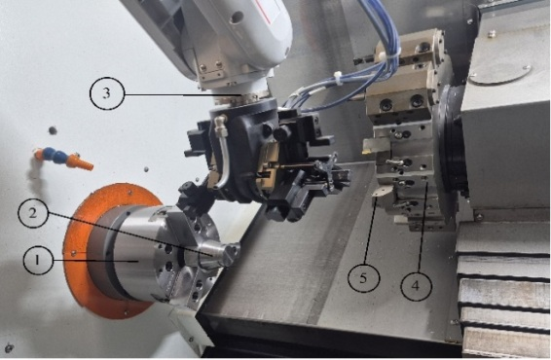
- Workspace of a HARRIS C400 CNC lathe with robotic power supply (1 – chuck; 2- workpiece; 3 - station for robotic power supply Mitsubishi robopro DR800; 4 – turret head; 5 – cutting tool)
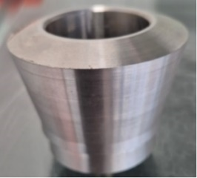 | 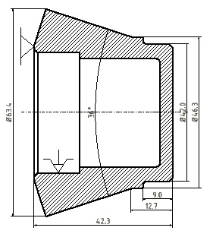
- Machined workpiece
The generalized arithmetic mean utility function with weighting coefficients is determined upon each trial according to the relationship:
$Φ_{Ah}=η_{1}.w_{1}+η_{2}w_{2}$, (2)
where: $w_{1}$ and $w_{2}$- weighting coefficients for the parameters cutting tool lifetime and turning process production rate, respectively; $η_{1}$ and $η_{2}$ - utility coefficients.
The values of the weighting coefficients are respectively: for $Φ_{A1}$ - $w_{1}=0.2$; $w_{2}=0.8$; for $Φ_{A2}$ - $w_{1}=0.8$; $w_{2}=0.2$. In the first case, a higher production rate of the turning process is ensured, and in the second - a greater tool lifetime of the cutting tool.
The utility coefficients $η_{1}$ and $η_{2}$ are given by the relationships:
$η_{1}=\frac{L-L_{u}}{L_{g}-L_{l}}k_{L}$; $η_{2}=\frac{t-t_{u}}{t_{g}-t_{l}}k_{t}$, (3)
where: $L_{g}=L_{max}$ and $L_{l}=L_{min}$ - utility limits of the tool lifetime parameter; $t_{g}=t_{max}$ and $t_{l}=t_{min}$ - utility limits of the production rate parameter; $L_{u}=L_{min}$ and $t_{u}=t_{max}$ - the most useless results of the investigated tool lifetime and production rate parameters obtained within the factor space; $k_{L}=+1$; $k_{t}=-1$ - coefficients accounting for the utility of the increase in the parameter under investigation.
2) The combinations of values of the control factors ($X_{1}^{*}=V_{c}^{*}$, $X_{2}^{*}=f^{*}$, $X_{3}^{*}=a_{p}^{*}$) in the studied factor space are determined, for which the generalized arithmetic mean utility functions with weighting coefficients $Φ_{Ah}$ have maximum value:
$$Φ_{Ah}\left(X_{1}^{*},X_{2}^{*},X_{3}^{*}\right)={\left(Φ_{Ah}\right)}_{max }>Φ_{Ah}\left(X_{1},X_{2},X_{3}\right) .$$
(4)
3) Pareto-optimal solutions are determined that guarantee the best combination between maximum tool lifetime and maximum production rate when turning hardened 42CrMo4 steel on a CNC lathe with robotic power supply.
Table 2 Factor levels in the experimental design
Factors |  | Factor levels
 |  | -1 | 0 | +1
$$X_{1}$$ | $V_{c}$ (m/min) | 180 | 230 | 280
$$X_{2}$$ | $a_{p }$(mm) | 2.0 | 2.5 | 3.0
$$X_{3}$$ | $f$ (mm/rev | 0.15 | 0.2 | 0.25

Results and discussion

A. Modelling of Generalized Utility Function
The design of the experiment with the values of the generalized arithmetic mean utility functions with weighting coefficients $Φ_{A1}$ and $Φ_{A2}$ determined according to relation (2), as well as the investigated turning process parameters (path L from the tool along the machined surface to reach roughness ${Ra}_{k}=2.0 µm$ and machining time t) are presented in Table 3. In specifying utility functions $Φ_{A1}$ and $Φ_{A2}$, the values of the most useless result and the utility limits of the turning process parameters are: for tool lifetime - $L_{u}=42 237 mm$; ${ L}_{g}=67 742 mm$; $L_{l}=42 237 mm$; for machining time - $t_{u}=427.92 min$; $t_{g}=427.92 min$; $t_{l}=102.9 min$.
After statistical analysis of the experimental results by applying the regression analysis method and QstatLab software [19], theoretical and experimental models for the generalized arithmetic mean utility functions $Φ_{A1}$ and $Φ_{A2}$ were constructed (Table 4).
The models include only the significant regression coefficients determined according to the condition $\hat{t}>t_{α/2, ν}$, where $\hat{t}$ and $t_{α/2,ν}$ are the calculated values of the Student’s t-criterion for each of the regression coefficients and the tabular value of the Student’s t-criterion, respectively (α=0.05 is the significance level; ν = N –k is the number of degrees of freedom; k is the number of coefficients in the model).
Regression models are adequate because the condition $\hat{F}>F_{α,ν_{1},ν_{2}}$ is met with a 95% confidence probability. The calculated $\hat{F}$ and tabular $F_{α,ν_{1},ν_{2}}$ values of the Fisher criterion (α=0,05; $ν_{1}=k-1$ and $ν_{2}=N-k$ are degrees of freedom) for each of the regression models are presented in Table 4. Theoretical and experimental models describe with high accuracy the dependencies between generalized utility functions $Φ_{A1}$ and $Φ_{A2}$ and the control factors. The values of the determination coefficients are ${\hat{R}}^{2}=0.971-0.988$ (Table 4).
The influence of cutting conditions on the generalized utility functions $Φ_{A1}$ and $Φ_{A2}$ is presented graphically in Fig. 3. To determine the degree of impact of the control factors on $Φ_{A1}$ and $Φ_{A2}$, Analysis of Variance (ANOVA) was carried out using QStatLab (version 6.1.1.3) [19]. The ANOVA interaction plots for the generalized utility functions are shown in Fig. 5.
Table 3 Design of the experiment and generalized utility functions
Control factors |  |  | CNC turning parameters |  | Utility coefficients |  | Generalized utility function
x₁ | x₂ | x₃ | L (mm) | t (min) | $$η_{1}$$ | $$η_{2}$$ | $$Φ_{A1}$$ | $$Φ_{A2}$$
-1 | -1 | -1 | 67 742 | 427.92 | 1 | 0 | 0.2 | 0.8
1 | -1 | -1 | 65 170 | 266 | 0.899 | 0.498 | 0.578 | 0.819
-1 | 1 | -1 | 47 547 | 295.17 | 0.208 | 0.408 | 0.368 | 0.248
1 | 1 | -1 | 46 312 | 187.5 | 0.160 | 0.74 | 0.624 | 0.276
-1 | -1 | 1 | 61 740 | 234 | 0.765 | 0.597 | 0.631 | 0.731
1 | -1 | 1 | 61 225 | 148.75 | 0.744 | 0.859 | 0.836 | 0.767
-1 | 1 | 1 | 42 237 | 159.6 | 0 | 0.826 | 0.661 | 0.165
1 | 1 | 1 | 42 360 | 102.9 | 0.005 | 1 | 0.801 | 0.204
-1 | 0 | 0 | 52 170 | 246.67 | 0.389 | 0.558 | 0.524 | 0.423
1 | 0 | 0 | 51 465 | 158.17 | 0.362 | 0.83 | 0.736 | 0.456
0 | -1 | 0 | 63 455 | 234.33 | 0.832 | 0.596 | 0.643 | 0.785
0 | 1 | 0 | 45 077 | 164.25 | 0.111 | 0.811 | 0.671 | 0.251
0 | 0 | -1 | 53 439 | 265.3 | 0.265 | 0.500 | 0.453 | 0.312
0 | 0 | 1 | 50 055 | 147.92 | 0.307 | 0.861 | 0.750 | 0.418
0 | 0 | 0 | 51 888 | 190.13 | 0.378 | 0.732 | 0.661 | 0.449
Table 4 Theoretical and experimental models of the generalized utility function and statistical characteristics of the models
Models | Fisher criterion |  | $${\hat{R}}^{2}$$
Models | $$\hat{F}$$ | $$F_{α,ν_{1},ν_{2}}$$ | $${\hat{R}}^{2}$$
$$Φ_{A1}=-3.2604+0.0076.V_{c}+$$  $$0.4815.a_{p}+18.061.f-22.72.f^{2}$$  $$-0.001.V_{c}.a_{p}-1.095.a_{p}.f$$  $$-0.0145.V_{c}.f$$ | 163.975 | 3.787 | 0.988
$$Φ_{A2}=3.8723+0.0003.V_{c}+$$  $$2.7545.a_{p}+6.5171.f+0.4406.a_{p}^{2}-17.1429.f^{2}$$ | 94.011 | 3.482 | 0.971

Both analysis of the theoretical and experimental models (Table 4) and the graphics plotted on the basis of them (Fig. 3), as well as the interpretation of ANOVA results (Fig. 4), allow us to draw the following conclusions:
a) The greatest influence on the generalized arithmetic mean utility function $Φ_{A1}$ is caused by the depth of cut, as its increase increases the value of $Φ_{A1}$ from 1.8 to 3 times. The effect of the depth of cut increases when the feed and cutting speed decrease. Speed of cutting also has a significant influence on $Φ_{A1}$, the increase of which in the studied range leads to an increase in the value of $Φ_{A1}$ up to 2.7 times.
b) The greatest influence on the generalized arithmetic mean utility function $Φ_{A2}$ is exerted by the feed, as its increase increases the value of $Φ_{A2}$ from 3.2 to 3.9 times. The influence of feed increases with increasing the depth of cut and decreasing the cutting speed.
These conclusions show that the cutting conditions have a different impact on the generalized arithmetic mean utility function, which depends on the way it is determined and is related to the different influence of cutting speed, feed and depth of cut on the cutting tool lifetime, defined by the path L (mm), and the turning production rate, estimated by the time t (min). The results of the study conducted by the authors show that the depth of cut has the greatest impact on machining time, and the feed has the greatest influence on the cutting tool lifetime.

B. Definition of Optimum Turning Conditions
The optimization problem for turning 42CrMo4 steel on a CNC lathe with robotic power supply was solved by applying a genetic algorithm and using the QStatLab software product. Optimal cutting conditions (cutting speed $V_{c}^{*}$, feed $f^{*}$ and depth of cut $a_{p}^{*}$) are those at which the generalized arithmetic mean utility functions $Φ_{A1}$ and $Φ_{A2}$ have a maximum (Table 5).
The determined Pareto-optimal solutions guarantee the best combination of tool lifetime and production rate when turning hardened 42CrMo4 steel on a CNC lathe with robotic power supply. Cutting conditions ($V_{c}^{*}$, $a_{p}^{*}$ и $f^{*}$) at which the generalized arithmetic mean utility function $Φ_{A1}$ has a maximum, provide higher production rate of the turning process, and those at which the generalized arithmetic mean utility function $Φ_{A2}$ has a maximum - higher lifetime of the cutting tool. Values of the tool path L, determined by way of experimentation as a parameter for assessing its lifetime, and of the machining time t are presented in Table 5.

Conclusions
In this paper, a new approach for the optimization of the turning process is proposed, which takes into account the specificity of its particular application in the machining of 42CrMo4 steel on a CNC turning machine with robotic power supply, using a cutting tool with a new type of replaceable carbide insert with CVD coating. As an optimization parameter, the generalized mean-arithmetic utility function with weighting coefficients is chosen, being a complex index characterizing the tool lifetime and process production rate.
Table 5 Optimum Turning Conditions
Optimal conditions |  |  | CNC turning parameters |  | Generalized utility function
$$V_{c}^{*}$$ | $$a_{p}^{*}$$ | $$f^{*}$$ | L | t | $$Φ_{A1}$$ | $$Φ_{A2}$$
m/min | mm | mm/rev | mm | min | $$Φ_{A1}$$ | $$Φ_{A2}$$
280 | 2.0 | 0.25 | 61 543.58 | 145,96 | 0.846 | -
280 | 2.0 | 0.19 | 63 742.49 | 200,16 | - | 0.832

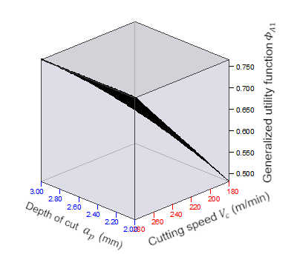 | 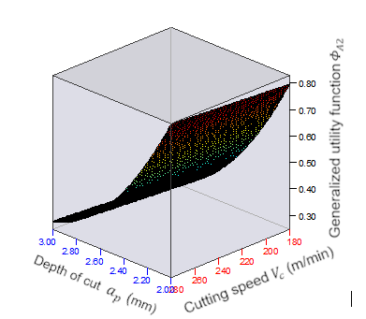
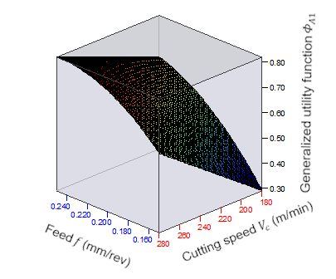 | 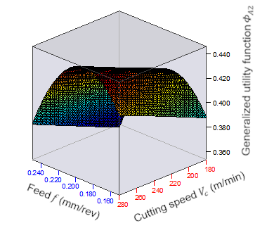
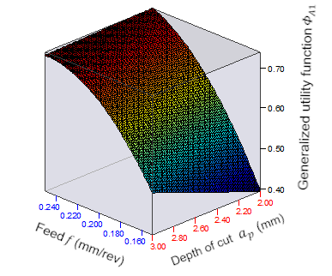 | 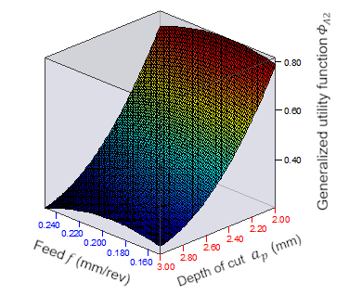
a) | b)
- Graphical visualization of the generalized utility function models for CNC turning: (a) arithmetic mean generalized utility function $Φ_{A1}$ with weighting coefficients $w_{1}=0.2$; $w_{2}=0.8$; (b) arithmetic mean generalized utility function $Φ_{A2}$ with weighting coefficients $w_{1}=0.8$; $w_{2}=0.2.$
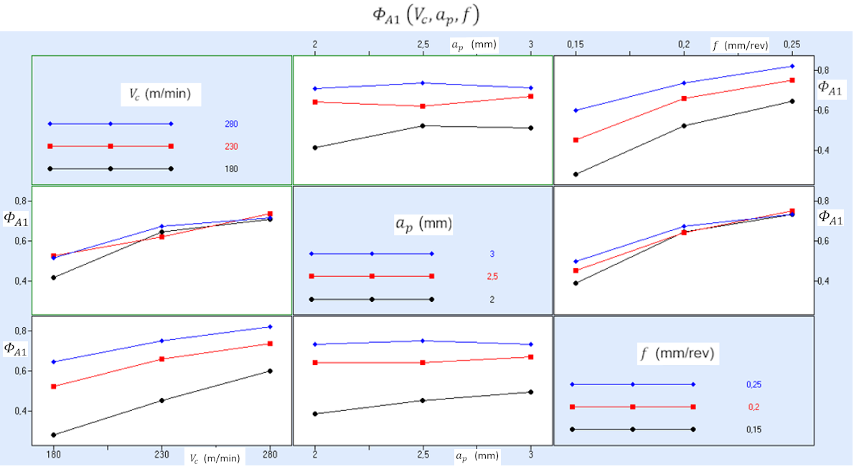
a)
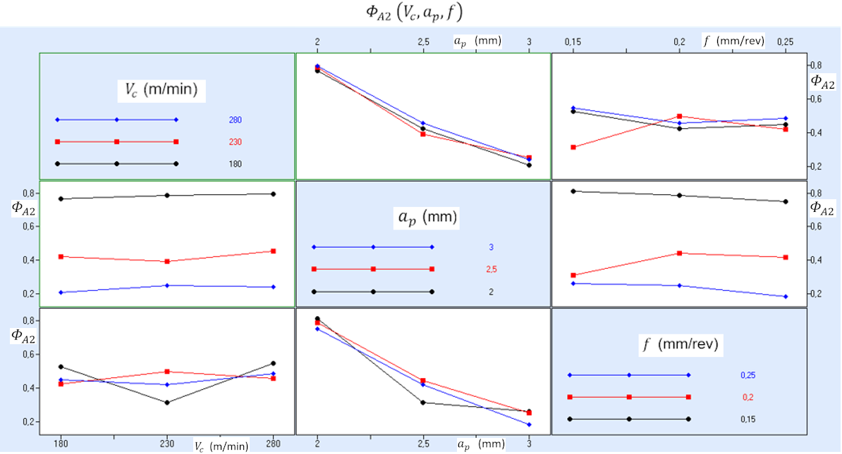
b)
- Interaction plots for the generalized utility function models for CNC turning: (a) arithmetic mean generalized utility function $Φ_{A1}$ with weighting coefficients $w_{1}=0.2$; $w_{2}=0.8$; (b) arithmetic mean generalized utility function $Φ_{A2}$ with weighting coefficients $w_{1}=0.8$; $w_{2}=0.2$.

The following results were obtained:
- Theoretical and experimental models have been constructed to determine the generalized utility function, reflecting the complex influence of the control factors of the turning process (cutting speed, cutting depth and feed). Said models are based on the results of comprehensive investigated of cutting tool lifetime, determined by the path L (mm), and turning production rate, estimated by the time t (min) depending on the cutting conditions.99
- By applying the generalized arithmetic mean utility function with weighting coefficients and a genetic algorithm, Pareto-optimal conditions for turning (cutting speed, cutting depth and feed) of hardened steel 42CrMo4 have been determined (Table 5). They provide the best combination of process production rate and cutting tool lifetime compared to the optimum conditions for machining hardened 42CrMo4 steel defined in [3]-[10] .
- . The production rate and tool lifetime of machining with the specified optimum cutting conditions (Table 5) with the new type of inserts are comparable to those of machining with CBN inserts [10], with tooling costs approximately three times less.
The results obtained by applying the new optimization approach allow an increasing of the efficiency and control of the turning process of 42CrMo4 steel. They can be used in all machine-building companies for processing parts with high strength and hardness (compressor parts, turbine parts, drive shafts, pump shafts, lathe spindles, working elements of heavy ground and underground machinery, parts for agricultural machinery etc.) from hardened 42CrMo4+QT steel on CNC lathes with robotic power supply. The new type of Iscar CXMG 12T508-M3P IC8150 replaceable carbide inserts used provide high tool lifetime and production rate related to their resistance to cracks, crater wear and flank wear well as adhesion to the substrate.

Acknowledgments
This research was funded by the European Regional Development Fund within the OP "Research, Innovation and Digitalization Programme for Intelligent Transformation 2021-2027", Project CoC "Smart Mechatronics, Eco- and Energy Saving Systems and Technologies", No BG16RFPR002-1.014-0005.
References
- L Mukherjee and P. K. Ray, "A review of optimization techniques in metal cutting processes." Computers&Industrial Engineering, vol. 50(1-2), pp. 15-34, 2006, https:// doi.org/10.1016/j.cie.2005. 10.001
- X. Wang, Z. J. Da, A. K. Balaji ,and I. S. Jawahir, "Performance-Based Predictive Models and Optimization Methods for Turning Operations and Applications: Part 3 - Optimum Cutting Conditions and Selection of Cutting Tools." Journal of Manufacturing Processes, vol. 9(1), pp. 61-74, 2007, https://doi.org/10.1016/S1526-6125(07)70108-1.
- E. Aslan, N. Camuscu, and B. Bingoren, "Design optimization of cutting parameters when turning hardened AISI 4140 (63 HRC) with Al2O3 + TiCN mixed ceramic tool." Materials & Design, vol. 28, pp. 1618-1622, 2007, https://doi:10.1016/j.matdes.2006.02.006.
- H. Akkuş, "Experimental and Statistical Investigation of Ra in Turning of AISI 4140." Sakarya University Journal of Science, vol. 23(5), pp. 775-781, 2019, https://doi.org/10.16984/saufenbilder.490668.
- S. R. Das, D. Dhupal, and A. Kumar, "Study of surface roughness and flank wear in hard turning of AISI 4140 steel with coated ceramic inserts." J Mech Sci Technol, vol. 29, pp. 4329–4340, 2015, https://doi.org/10.1007/s12206-015-0931-2.
- A.R Motorcu, Y. Isik, A. Kus, and M.C. Cakir, "Analysis of the cutting temperature and surface roughness during the orthogonal machining of AISI 4140 alloy steel via the taguchi method." Materiali in Tehnologije, vol. 50(3), pp. 343-351, 2016.
- G. Sharan and R. K. Patel, "Optimization of cutting parameters of turning for hardness of AISI 4140 alloy steel." in ICMPC-2019, Materials Today: Proceedings, vol. 18, pp. 3582–3589, 2019.
- B. Hamadi, M.A. Yallese, L. Boulanouar, A Hammoudi, and M. Nouioua. "Evaluation of the cutting performance of PVD, CVD and MTCVD carbide inserts in dry turning of AISI 4140 steel using RSM-based NAMDE optimization." J Braz. Soc. Mech. Sci. Eng. vol. 44, pp. 342⁺, 2022. https://doi.org/10.1007/s40430-022-03633-5.
- Padhan, N.K.Wagri. L. Dash, A. Das, S.R. Das, M. Rafighi, and P. Sharma, "Investigation on Surface Integrity in Hard Turning of AISI 4140 Steel with SPPP-AlTiSiN Coated Carbide Insert under Nano-MQL." Lubricants, vol. 49(11), 2023, https://doi.org/10.3390/lubricants11020049.
- I. Meddour, M.A. Yallese, H. Bensouilah, A. Khellaf and M. Elbah, "Prediction of surface roughness and cutting forces using RSM, ANN, and NSGA-II in finish turning of AISI 4140 hardened steel with mixed ceramic tool." Int J Adv Manuf Technol, vol. 97, pp. 1931–1949, (2018), https://doi.org/10.1007/s00170-018-2026-6.
- V. S. Konnur, S. S. Kulkarni, S. V. Hiremath, V.S. Kanal, and V.C Nirale, "Analysis of CNC turning parameters and simultaneous optimisation of surface roughness and material removal rate by MOGA for AISI 4340 alloy steel." Advances in Materials and Processing Technologies, 12 Nov 2023, https://doi.org/10.1080/2374068X.2023.2280293.
- O. Manav, S. Chinchanikar, and M. Gadge, "Multi-performance optimization in hard turning of AISI 4340 Steel using Swarm Optimization technique", in IConAMMA_2017, Materials Today: Proceedings, vol. 5, pp. 24652–24663, 2018.
- R. Q. Sardiñas, M. R. Santana, and E. A. Brindis, "Genetic algorithm-based multi-objective optimization of cutting parameters in turning processes." Particle Engineering Applications of Artificial Intelligence, vol. 19(2), pp. 127-133, 2006, https://doi.org/10.1016/j.engappai.2005.06.007.
- S. Chinchanikar and S. K. Choudhury, "Effect of work material hardness and cutting parameters on performance of coated carbide tool when turning hardened steel: An optimization approach." Measurement, vol. 46, pp. 1572-1584, 2013, https://doi.org/10.1016/j.measurement. 2012.11.032.
- A. Aleksandrov and I. Aleksandrova, Theory of Experiment, Gabrovo, Bulgaria: Experess, 2012.
- S. Kumari, D. Bandhu, A. Kumar, R. K. Yadav, K. Vivekananda, "Application of Utility Function Approach Aggregated with Imperialist Competitive Algorithm for Optimization of Turning Parameters of AISI D2 Steel.“ in Lecture Notes in Intelligent Transportation and Infrastructure, Recent Advances in Mechanical Infrastructure, A. Parwani, P. Ramkumar, Eds. Singapore: Springer, 2020, https://doi.org/10.1007/978-981-32-9971-9_6.
- "Overview of 42CrMo4 Steel: Properties and Applications.” [Online]. Available: https://ambhe.com/42crmo4-steel/. [Accessed: Feb. 16, 2025].
- "ISCAR Cutting Tools - Metal Working Tools.” [Online]. Available: https://www.iscar.bg/index.aspx/countryid/38/lang/bg. [Accessed: Feb. 16, 2025].
- I. N. Vuchkov and I. I. Vuchkov, Statistical methods of quality control, robust engineering, planning, modeling and optimization, QStatLab, v 5.3, 2009.

